This amazing book should be essential reading for everyone involved with film societies in Australia.
Ask your local library to purchase a copy!

THE HISTORY OF AUSTRALIAN FILM SOCIETIES
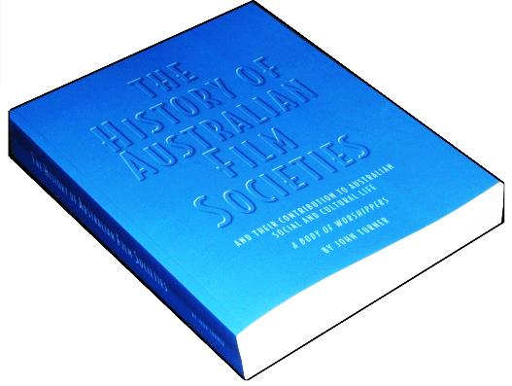
Written by JOHN TURNER and produced by ACOFS.

It is a very detailed tribute to all those who have participated in the Film Society movement over seventy years. It includes over 50 personalities, 40 film societies, six state Federations and many Australia-wide organisations.
There are 554 packed pages, including many photos!
Read all about-
- The contribution made to the social and cultural life of Australia by the film society movement.
- What was, and when was, the first film society formed?
- Why were State Federations created?
- Are national film society bodies necessary?
- Who were the movers and shakers making the film movement so important?
- Creation of the AFI and the major Film Festivals, and why ultimately, these organisations had to go it alone.
- The popularity of film weekends.
- The influence on censorship laws and other Government policies.
- Relationships between film societies and the major non-theatrical film bodies, especially the Non-Theatrical Lending Collection and the National Film and Sound Archive.
- The early involvement with State Film Centres and the National Film Theatre of Australia.
- A chronological account of the major events at state and national levels.
- An examination of publications from film society newsletters to country-wide catalogues and magazines, often widely circulated outside the movement.
- Which films were important to societies over the past seventy years?
- Appendices listing all significant dates, office bearers of Federations and ACOFS, and people mentioned in the book.

ACOFS has made copies available to all State Film Society Federations affiliated with ACOFS, at a discounted rate of $50 per book. All societies affiliated with their State Federation are being offered copies of the book, in most cases subsided by their Federation. If you are in an organisation affiliated with a State Federation contact your Federation to determine the actual purchase price for you.

Additional copies will be charged at $50 each for purchases made through member societies or Federations, or $75 to others purchased directly from ACOFS.

Member organisations of the FVFS (Victoria) to use this ORDER FORM to receive one fully subsidised copy of:
THE HISTORY OF AUSTRALIAN FILM SOCIETIES

Ordered by ……………….…………………………. (Official organisation Name)

Email …………………………………………….
One copy of the book is available, fully subsidised, to every current member of the FVFS. But we will need to charge you postage and handling of $15, if posted.

To request a FREE copy of the book, the President, Secretary or Treasurer of the member organisation should complete this order form (or a copy of it) and return it to the FVFS secretary. Tell us how you intend to collect the book. (You may collect it from Mitcham Vic)

FVFS Secretary, c/o 17 Bruce St. Mitcham Vic. 3132, or secretary@fvfs.org.au.

Your postal address (if it is to be posted)

Name ………………………………………………………………………………

Address ……………………………………………………………………………
If posted, payment of $15 per book is to be made by cheque/cash/EFT/other…..
(Please circle your choice) An invoice will be sent to you if requested.

Cheques are to be made payable to “Federation of Victorian Film Societies” and sent with this order form to the Treasurer at 17 Bruce St Mitcham, Vic. 3132.

Or pay by EFT to Federation of Victorian Film Societies, NAB Ringwood,
BSB: 083 343, A/c 56926 1432, and quote your surname and HISTORY.

If you pay by EFT, we still need your order form as above.

Use this ORDER FORM to purchase additional copies if your organisation is a member of an ACOFS affiliated Federation.

THE HISTORY OF AUSTRALIAN FILM SOCIETIES

Delivery address:
Name ………………………………………………………………………………

Address ……………………………………………………………………………

Email …………………………………………….

Ordered through ……………….…………………… (Society/Film Federation)

Endorsed by (print name) ………………………………………………….
(Society President/Secretary or Treasurer)

Quantity --------------at $50 each …………..$..........
Post and handling $15 per book (if posted)..$...........
Total due……………………………………$ ……..

An invoice can be sent to you if requested.

Payment to be made through cheque/cash/EFT/other…..…(Please circle your choice)

Cheques are to be made payable to “Australian Council of Film Societies” and sent with this order form to John Turner, 20 Craithie Avenue, Park Orchards, Vic 3114.
Or pay by EFT to Australian Council of Film Societies, NAB Melbourne,
BSB: 083 004, A/c 5617 98446, and quote your surname and HISTORY.

If you pay by EFT, please send your order form to the above postal address or email to treasurer@acofs.org.au

Use this ORDER FORM for non-members to purchase copies of:
THE HISTORY OF AUSTRALIAN FILM SOCIETIES

Delivery address:
Name ………………………………………………………………………………

Address ……………………………………………………………………………

Email …………………………………………….

Quantity --------------at $75 each …………..$..........
Post and handling $15 per book (if posted)..$...........
Total due……………………………………$ ……..

An invoice can be sent to you if requested.

Payment to be made through cheque/cash/EFT/other…..…(Please circle your choice)

Cheques are to be made payable to “Australian Council of Film Societies” and sent with this order form to John Turner, 20 Craithie Avenue, Park Orchards, Vic 3114.
Or pay by EFT to Australian Council of Film Societies, NAB Melbourne,
BSB: 083 004, A/c 5617 98446, and quote your surname and HISTORY.

If you pay by EFT, please send your order form to the above postal address or email to treasurer@acofs.org.au

